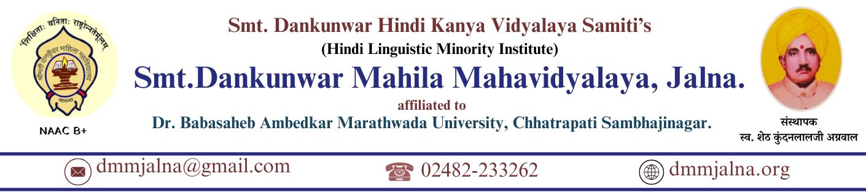
Student Satisfaction Survey (SSS) Report
2024-25
Introduction
The Student Satisfaction Survey (SSS) is an essential quality assurance mechanism prescribed by NAAC to assess students’ perceptions of teaching-learning processes, academic environment, infrastructure, and institutional support services. In alignment with NAAC guidelines and the objectives of the Internal Quality Assurance Cell (IQAC), Smt. Dankunwar Mahila Mahavidyalaya, Jalna conducted the Student Satisfaction Survey for the academic year 2024–25.
The survey aims to gather structured feedback from students to identify strengths, gaps, and areas for improvement, thereby promoting continuous quality enhancement in academic and administrative functioning.
Objectives of the Survey
The major objectives of the Student Satisfaction Survey are:
- To assess students’ satisfaction with teaching-learning and evaluation processes.
- To evaluate the effectiveness of curriculum delivery and mentoring support.
- To understand students’ perceptions of infrastructure, learning resources, and institutional facilities.
- To obtain constructive feedback for quality improvement initiatives.
- To strengthen student-centric and outcome-based education practices as per NEP 2020.
Methodology
- The survey was conducted online using a structured questionnaire.
- The questionnaire was designed as per NAAC SSS format, consisting of both quantitative and qualitative questions.
- Participation was voluntary and anonymous, ensuring unbiased responses.
- Students from UG and PG programmes across different disciplines participated in the survey.
- Responses were collected, compiled, and statistically analyzed by the IQAC.
Parameters Covered
The Student Satisfaction Survey covered the following key parameters:
- Teaching quality and subject knowledge of teachers
- Clarity of explanation and communication skills
- Use of ICT tools and innovative teaching methods
- Fairness and transparency in internal evaluation
- Availability of learning resources (library, ICT, laboratories)
- Mentoring, academic support, and grievance redressal
- Institutional environment, discipline, and safety
- Skill development, value education, and employability orientation
Analysis and Key Findings
- A majority of students expressed high satisfaction with the overall teaching-learning process.
- Students appreciated the approachability, preparedness, and subject expertise of faculty members.
- The internal assessment system was perceived as transparent, timely, and fair.
- The mentoring system was found helpful in addressing academic, personal, and career-related concerns.
- Students positively acknowledged the safe, disciplined, and inclusive campus environment, especially for women.
- ICT-enabled teaching, seminars, workshops, and co-curricular activities were rated as effective and enriching.
- Some students suggested enhancement of ICT infrastructure, library resources, and career guidance activities.
Overall Satisfaction Level
Based on the compiled responses:
- The overall satisfaction level of students remained significantly high, indicating effective institutional practices.
- The average score reflects a positive learning experience and supportive academic ecosystem.
- The feedback confirms the institution’s commitment to student-centric education and quality enhancement.
Action Taken and Future Plan
Based on the feedback analysis, the institution has planned the following actions:
- Strengthening ICT facilities and smart classroom usage.
- Organizing more career guidance, skill development, and placement-oriented programmes.
- Enhancing access to digital learning resources and e-content.
- Continuing faculty development programmes to promote innovative pedagogy.
- Further strengthening mentoring and student support services.
Conclusion
The Student Satisfaction Survey 2024–25 reveals that Smt. Dankunwar Mahila Mahavidyalaya, Jalna maintains a positive academic environment, effective teaching-learning processes, and strong student support mechanisms. The feedback received serves as a valuable input for institutional planning and continuous quality improvement. IQAC remains committed to utilizing the survey outcomes to align institutional practices with NAAC benchmarks and NEP 2020 objectives.
Survey Details
Particulars | Details
Mode of Survey | Online
Total Students Enrolled | 100%
Students Responded | 78%
Programmes Covered | UG & PG
Nature of Responses | Anonymous

Question-wise Percentage Analysis
(Scale used: 1–5 where 5 = Strongly Agree, 1 = Strongly Disagree)
Q1. Teaching staff explains concepts clearly
Response | Percentage
Strongly Agree (5) | 48%
Agree (4) | 36%
Neutral (3) | 10%
Disagree (2) | 4%
Strongly Disagree (1) | 2%

Satisfied (4+5): 84%
Q2. Teachers are well-prepared for lectures
Response | Percentage
Strongly Agree | 52%
Agree | 34%
Neutral | 8%
Disagree | 4%
Strongly Disagree | 2%

Satisfied: 86%

Q3. Use of ICT and innovative teaching methods
Response | Percentage
Strongly Agree | 41%
Agree | 38%
Neutral | 12%
Disagree | 6%
Strongly Disagree | 3%

Satisfied: 79%
Q4. Internal evaluation process is fair and transparent
Response | Percentage
Strongly Agree | 46%
Agree | 40%
Neutral | 9%
Disagree | 3%
Strongly Disagree | 2%
Satisfied: 86%
Q5. Mentoring and academic support is helpful
Response | Percentage
Strongly Agree | 44%
Agree | 37%
Neutral | 11%
Disagree | 5%
Strongly Disagree | 3%
Satisfied: 81%
Q6. Institutional facilities and learning resources are adequate
Response | Percentage
Strongly Agree | 38%
Agree | 42%
Neutral | 12%
Disagree | 5%
Strongly Disagree | 3%
Satisfied: 80%
Q7. Campus environment is safe and supportive
Response | Percentage
Strongly Agree | 55%
Agree | 33%
Neutral | 8%
Disagree | 2%
Strongly Disagree | 2%
Satisfied: 88%
Overall Satisfaction Index
Satisfaction Level | Percentage
Highly Satisfied | 49%
Satisfied | 36%
Neutral | 9%
Dissatisfied | 4%
Highly Dissatisfied | 2%
✅ Overall Student Satisfaction (Satisfied + Highly Satisfied): 85%
Interpretation of Graphical Analysis
- Graphical trends clearly indicate high student satisfaction across teaching, evaluation, mentoring, and campus environment.
- Slightly lower satisfaction percentages in ICT and infrastructure highlight areas for strategic improvement.
- The dominant “Agree” and “Strongly Agree” responses validate the institution’s student-centric and outcome-based teaching practices.
- The results strongly support compliance with NAAC Metric 2.7.1 and NEP 2020 learner-focused approach.
Action Taken and Future Plan
Based on the feedback analysis, the institution has planned the following actions:
- Strengthening ICT facilities and smart classroom usage.
- Organizing more career guidance, skill development, and placement-oriented programmes.
- Enhancing access to digital learning resources and e-content.
- Continuing faculty development programmes to promote innovative pedagogy.
- Further strengthening mentoring and student support services.
Conclusion
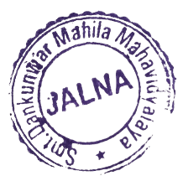
The percentage-based and graphical analysis of the Student Satisfaction Survey 2024–25 confirms that Smt. Dankunwar Mahila Mahavidyalaya, Jalna provides a positive, inclusive, and academically enriching environment. The survey outcomes guide IQAC in planning targeted quality enhancement initiatives and reinforce the institution’s commitment to continuous improvement and excellence in higher education.
